Exercise 1: Setting Up Junit

Pom.xml

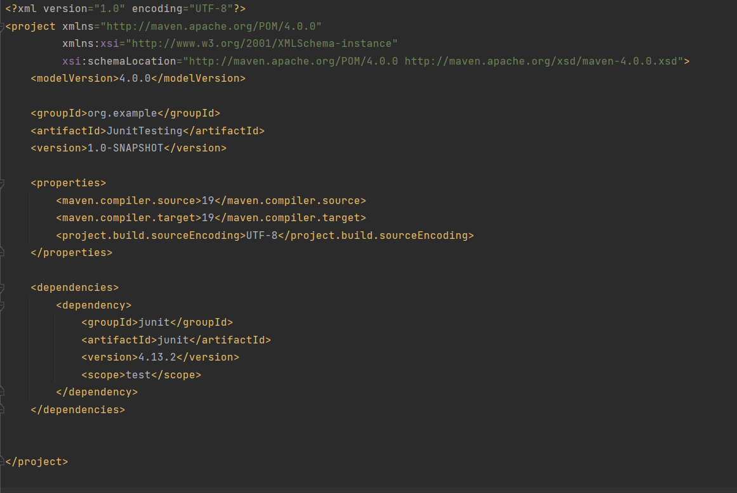

Test class- MainTest.java

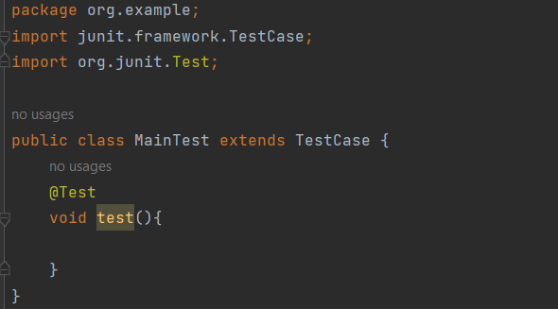

Exercise 3: Assertions in Junit

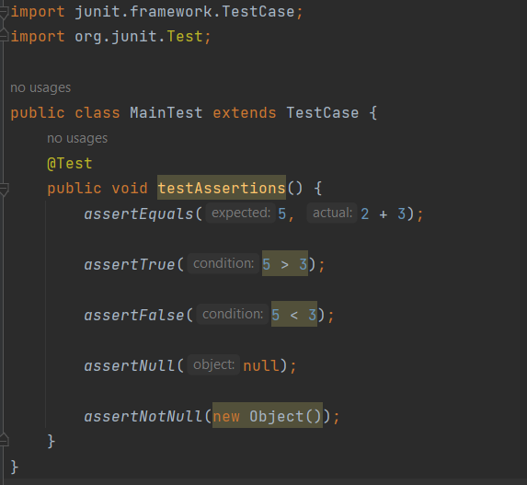

Output:

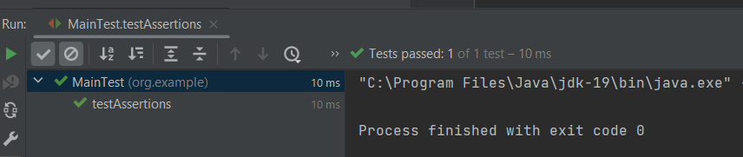

Exercise 4: Arrange-Act-Assert (AAA) Pattern, Test Fixtures, Setup and

Teardown Methods in Junit

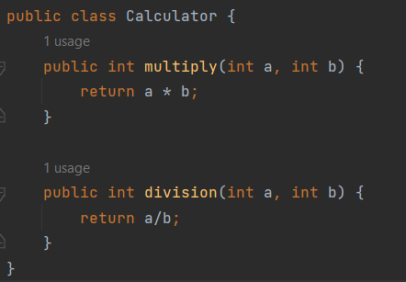

Test class

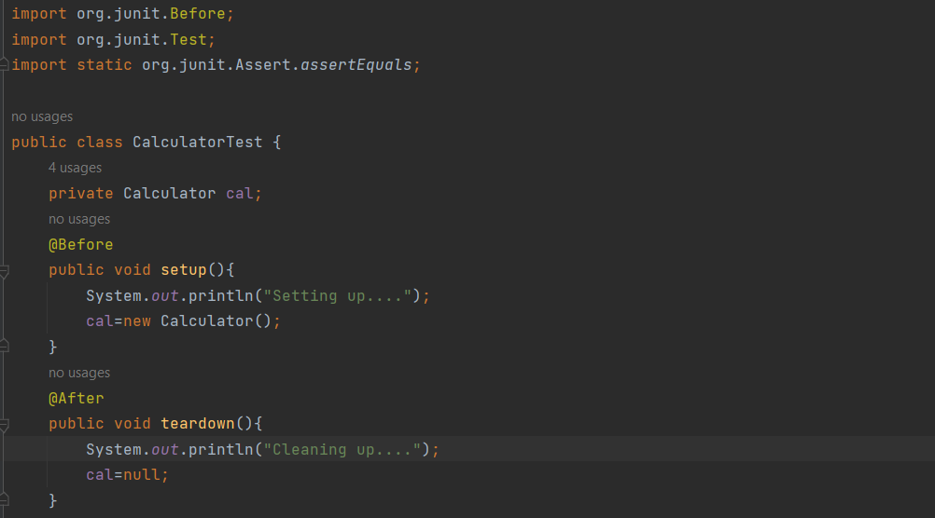

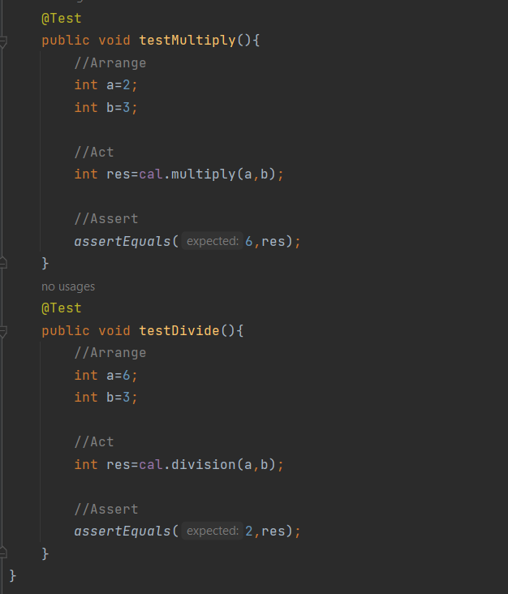

Output:

